**Assignment No:-53**

Name:-Suryawanshi Sangramsingh Sambhaji

Batch: - Delta - DCA (Java) 2024 Date:-25/7/2024

**Q1.You have been given a task to analyze a text file using Java file handling. Your goal is to determine the frequency of each character present in the file. Write a Java program that reads the content of a specified text file and calculates the frequency of each character (including letters, digits, punctuation, and whitespace). Implement this program using file**

**handling concepts in Java.**

**Your program should be able to answer the following questions:**

**1.How many times does each character appear in the file?**

**2.Which character appears the most frequently?**

**3.Are there any characters that do not appear in the file?**

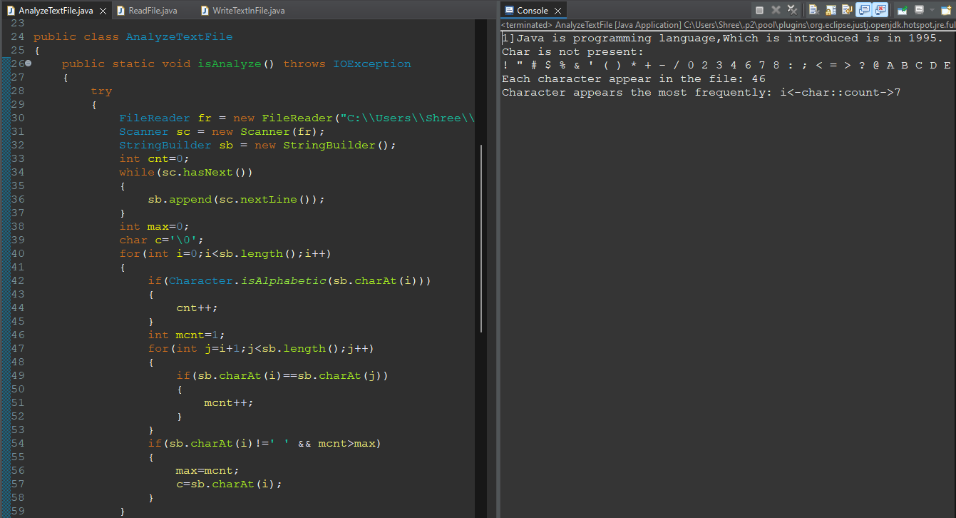

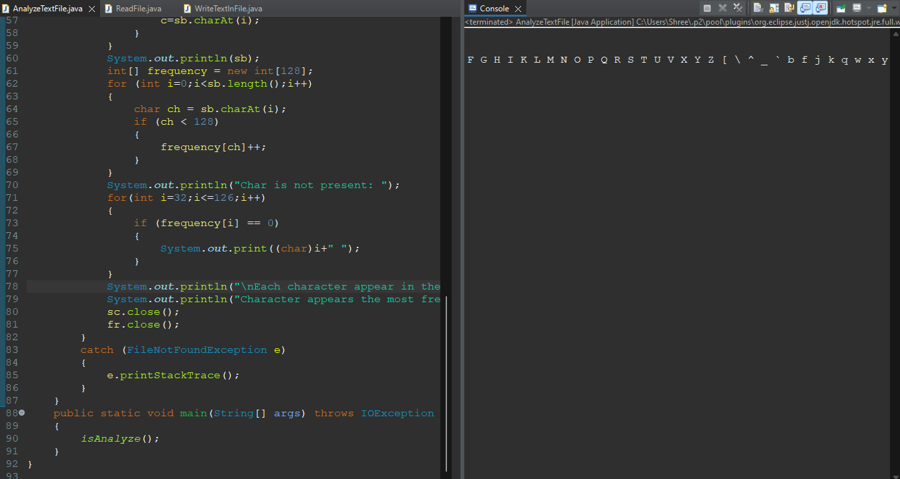

**Q.2 You are given two text files, file1.txt and file2.txt, both of which contain a list of names. Your task is to find names that are common to both files and write them to a new file called common_names.txt.**

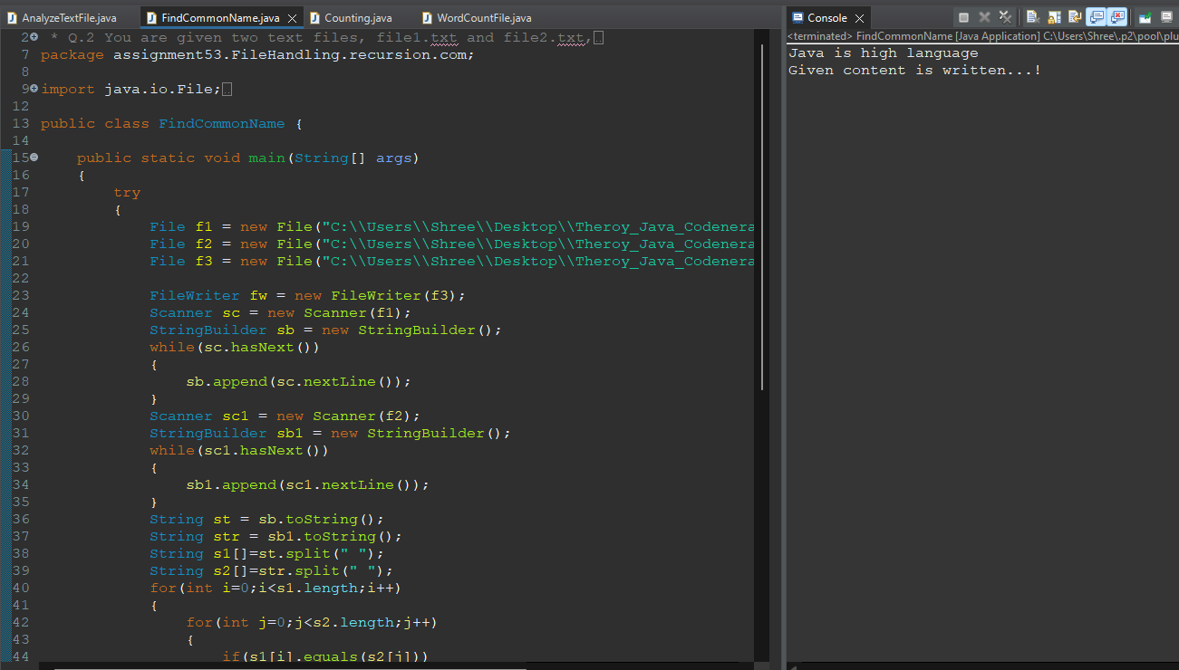

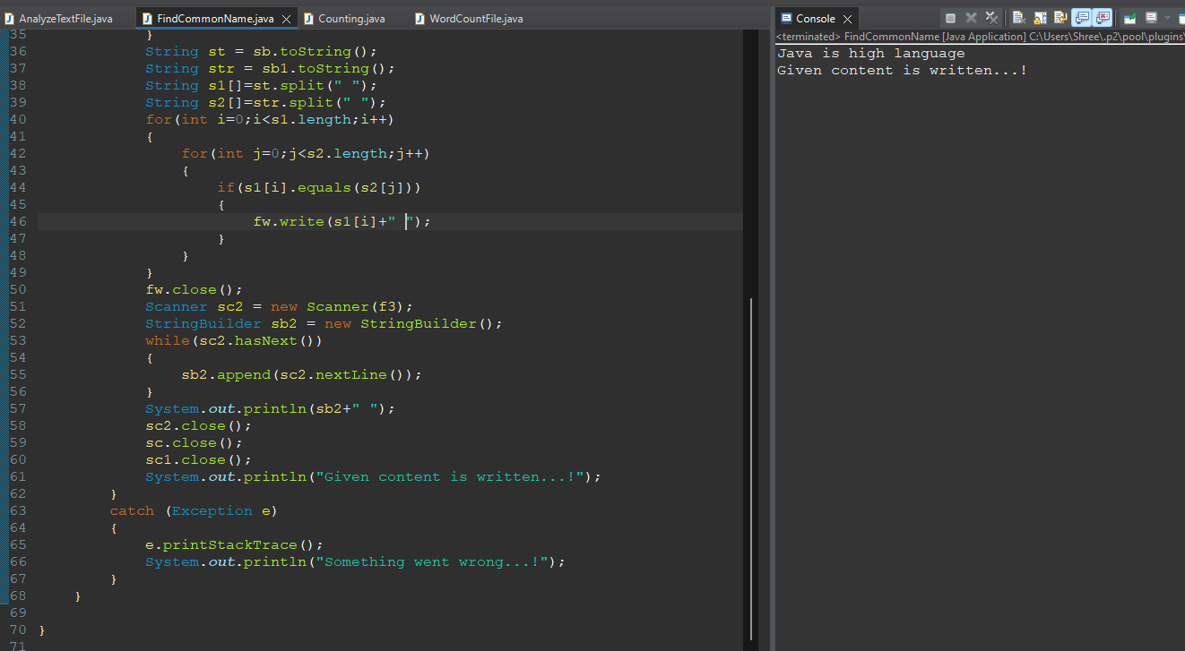

**Q3. Create a Java program that reads a given text file and performs word counting .**

**Consider whitespace and punctuation as word separators.**

**Your program should display both the total word count and a list of unique words present in the file .**

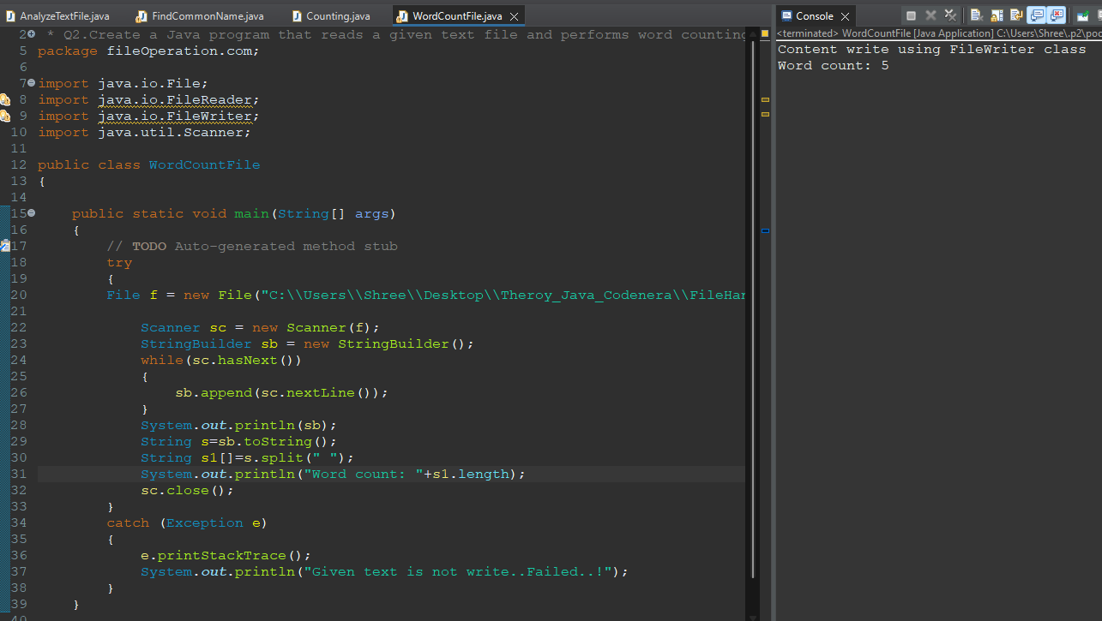

**Q4. Write a Java program to append text to an existing file.**

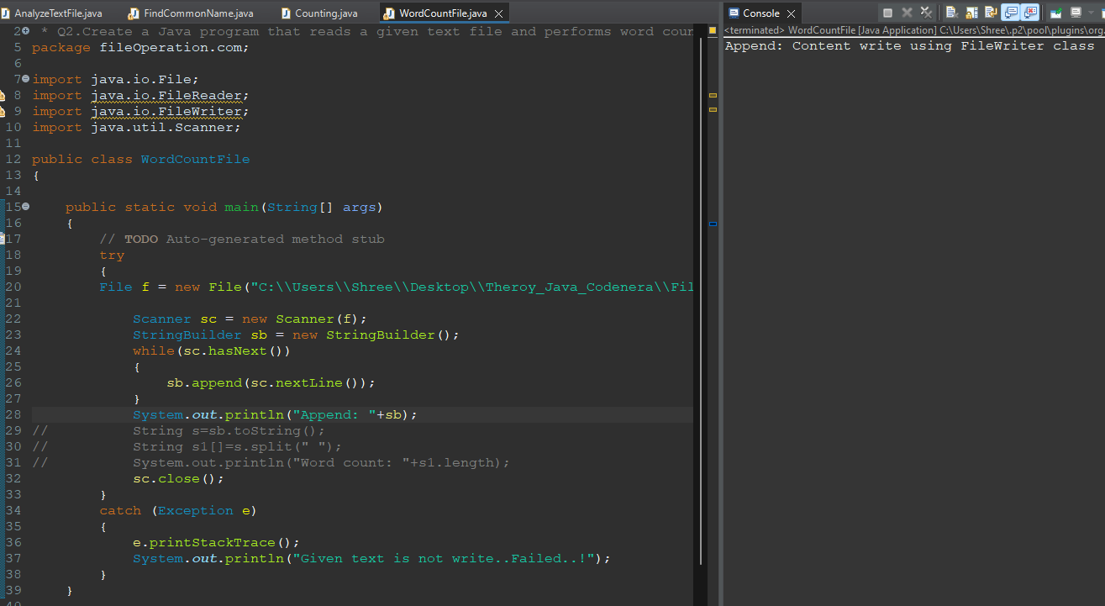

**Q5. Write a Java program to find the longest word in a text file.**

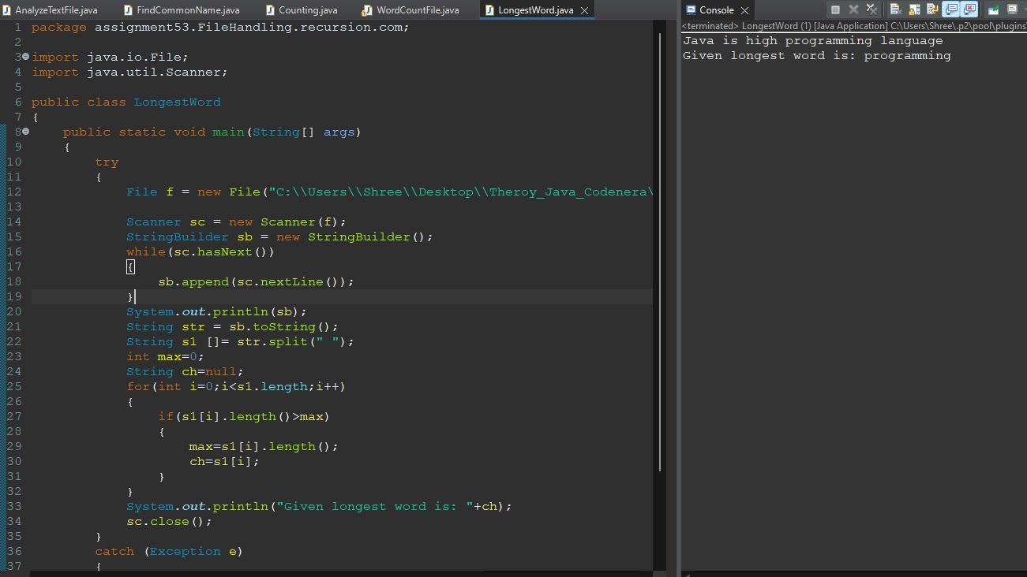

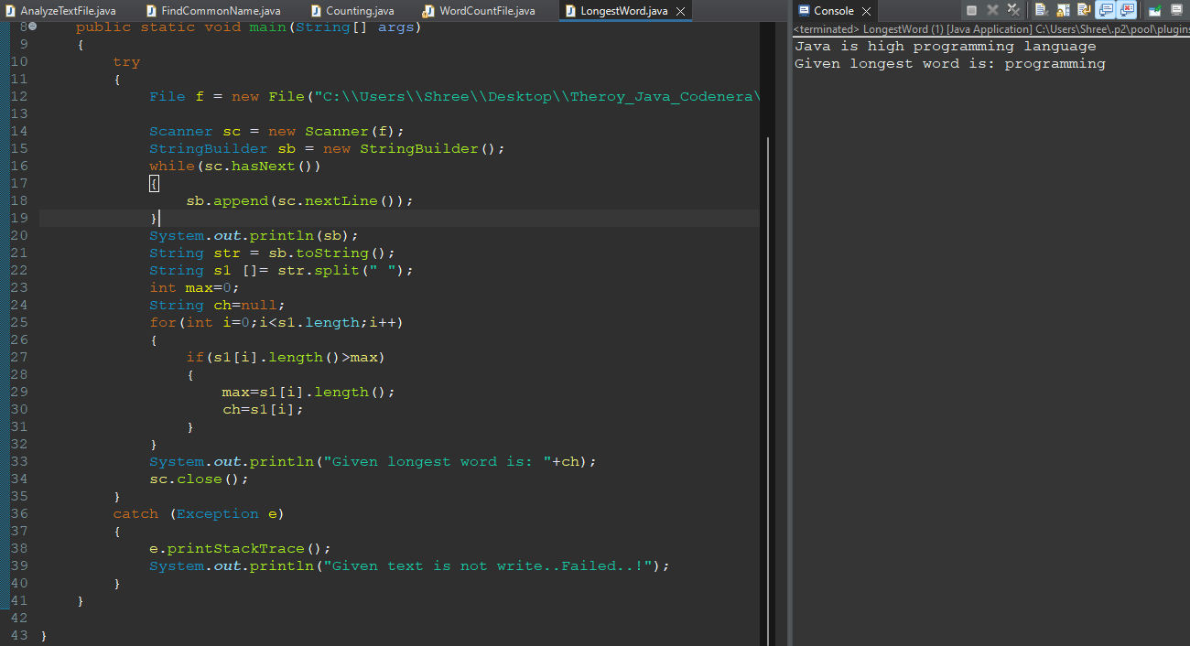

**Q6. write a java program to handle the all operations as per user choice ,Ex : 1. create file 2. write the content in file 3. read the content from file 4. delete the given file.**

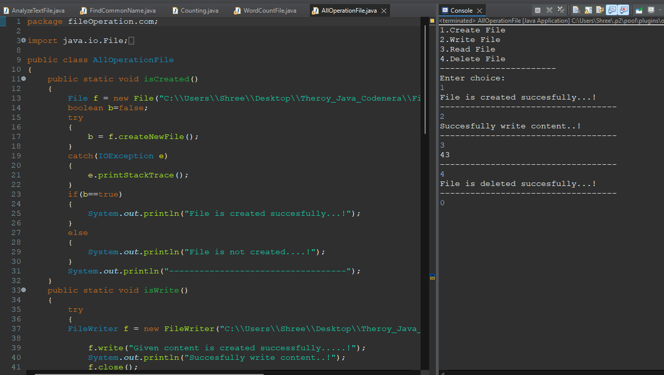

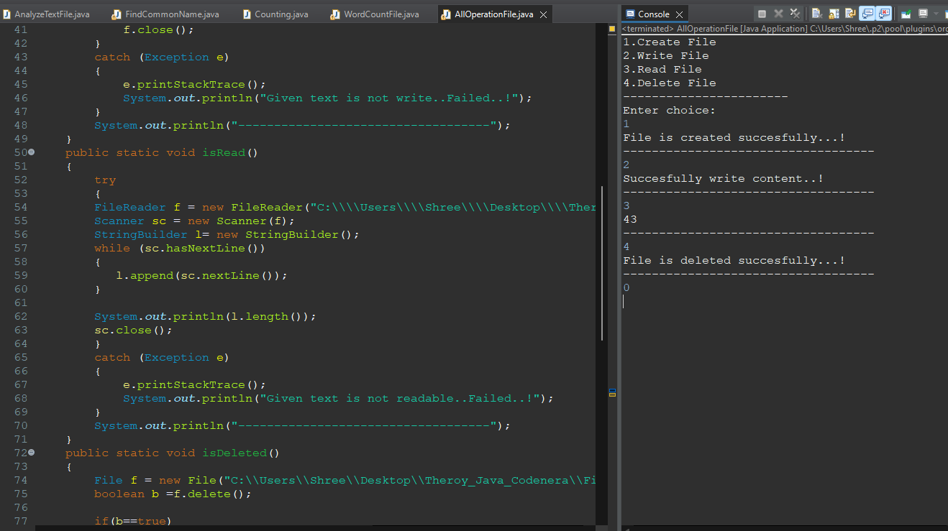

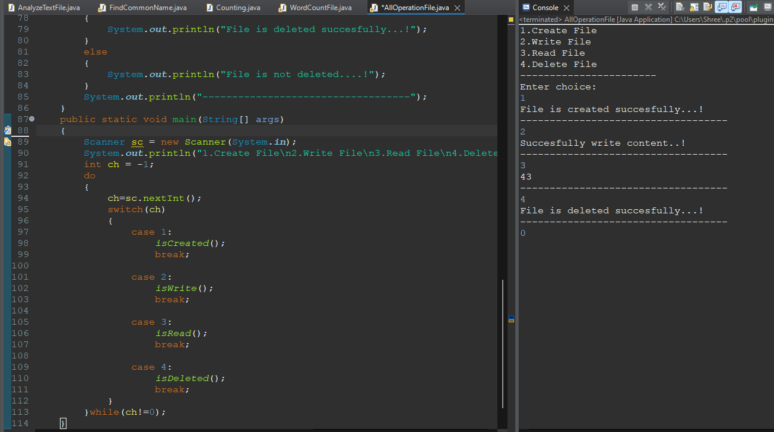

**---------------------------------------------------------------------------------------------------------------------**

**Q1.Create a recursive function to find the Reverse of given number**

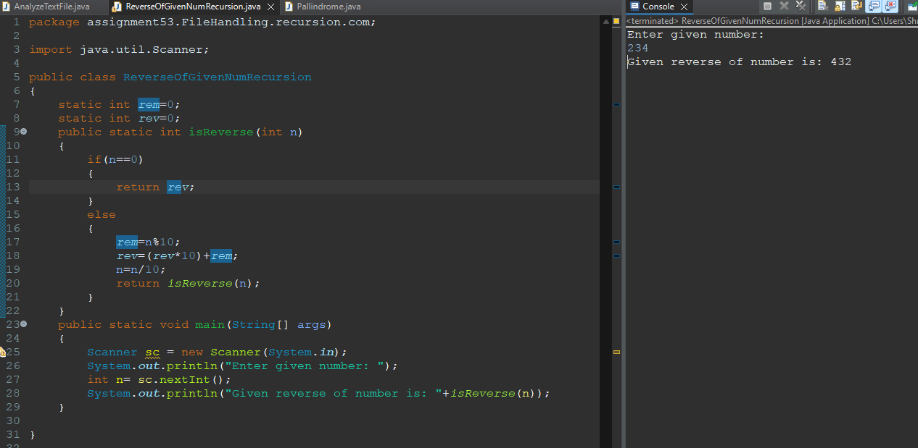

**Q2.Create a recursive function to find the sum of all elements in an array of integers in Java.**

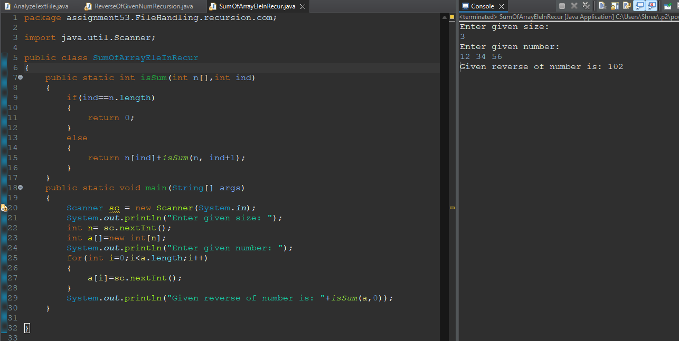

**Q3.Create a recursive function to check the given number is palindrome or not.**

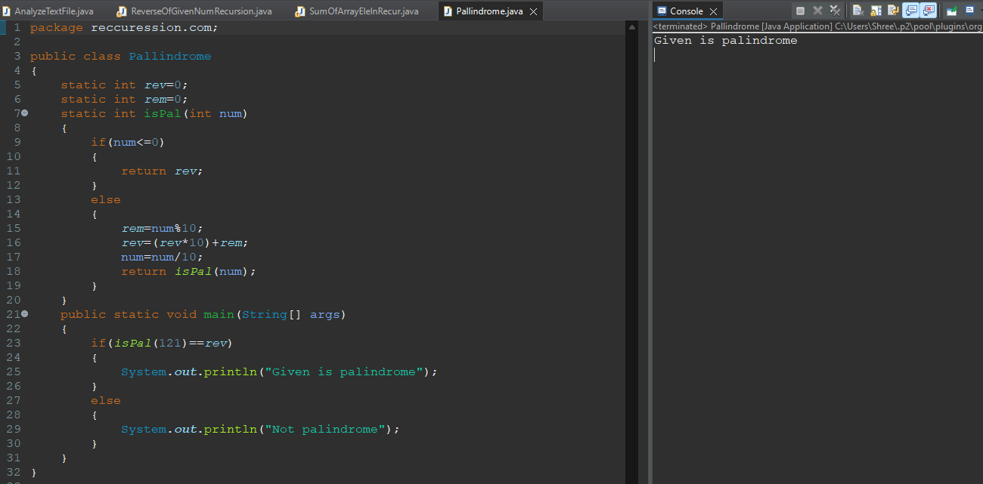

**Q4.Create a recursive function to find the factorial of given number.**

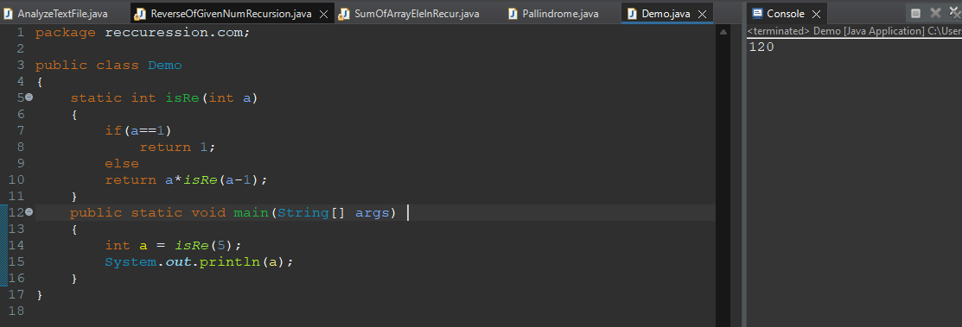

**Q5.Create a recursive function to find the power of given number.**

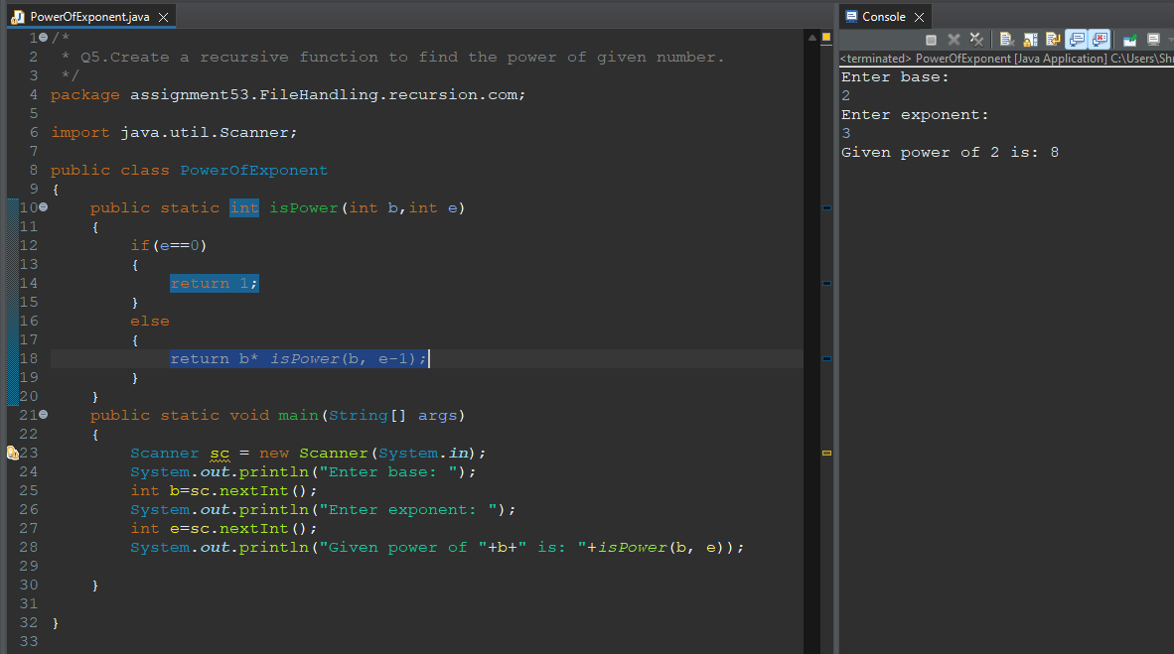

**Q6.Create a recursive function to check the given String is palindrome or not.**

